**Create a simple cloud software application for Property Buying &amp; Rental process (In Chennai city) using any Cloud Service Provider to demonstrate**

**Aim**

To design and deploy a cloud-based application in **Zoho Creator** for managing **Property Details** and **Tenant Details** in the **Property Buying and Rental process (Chennai city)**, and to demonstrate the concept of **Software as a Service (SaaS)**.

**Procedure**

1. **Create Application**
   * Log in to Zoho Creator.
   * Create a new application named Chennai Property Buying & Rental System.
2. **Design Property Details Form**
   * Add fields:
     + Property ID (Auto Number)
     + Owner Name (Single Line)
     + Property Type (Dropdown: Apartment, Villa, Plot, Commercial)
     + Location (Dropdown: Egmore, T. Nagar, Velachery, Adyar, Anna Nagar)
     + Price (Number)
     + Status (Dropdown: Available, Not Available)
3. **Design Tenant Details Form**
   * Add fields:
     + Tenant Name (Single Line)
     + Age (Number)
     + Contact Number (Phone)
     + Email (Email field)
     + Requirement Type (Dropdown: Buy, Rent)
     + Preferred Location (Dropdown: Egmore, T. Nagar, Velachery, Adyar, Anna Nagar)
4. **Create Reports**
   * Property Listings Report → displays all available properties.
   * Tenant List Report → displays all tenant details.
5. **Deploy as SaaS**
   * Save and share the application in Zoho Creator.
   * The app is hosted on the cloud → accessible via browser or mobile as a SaaS solution.

OUTPUT:

PROPERTY DETAILS:

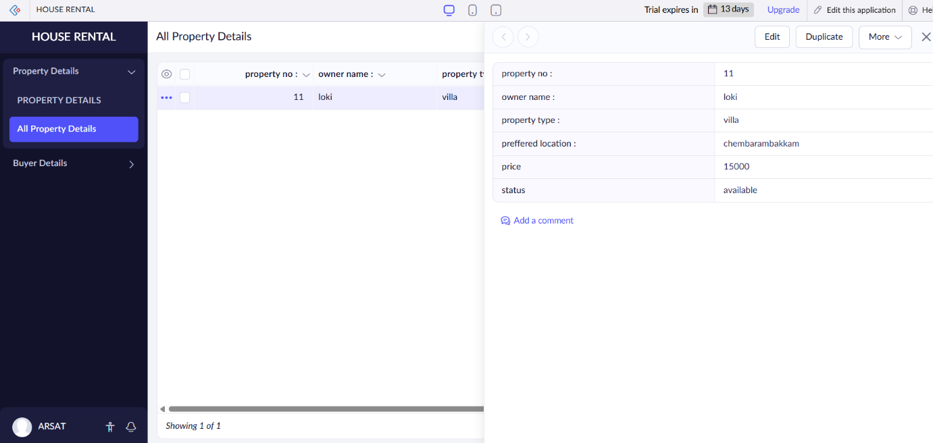

BUYER DETAILS:

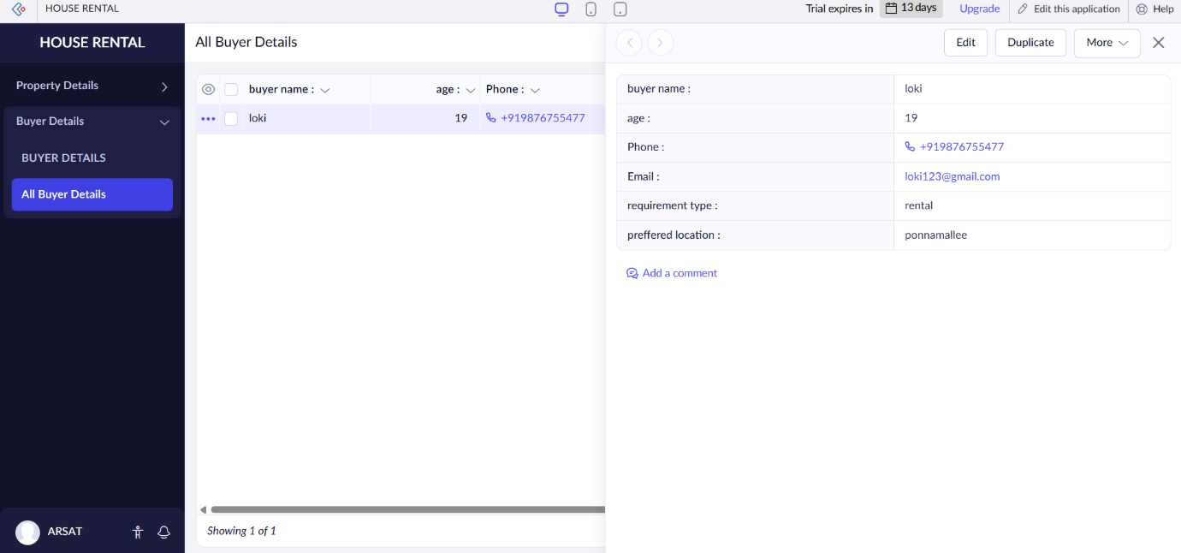

**Result**

A cloud-based Property Buying & Rental application was successfully developed in Zoho Creator with two modules: